**A) Simple Pendulum**

SOURCE CODE:

**clc**

clear

clf

l = 10 *//input("Enetr length: ")*

y0=[%pi/4;0]

t0=0;

T=2*%pi*sqrt(l/9.8)

t=0:0.01:T

function **p**=f(**t**, **y**)

**p**(1)=**y**(2)

**p**(2)=(-9.8/l)*sin(**y**(1))

endfunction

y=ode(y0,t0,t,f)

a=gca()

a.x_location="origin";

a.y_location="origin";

plot2d(t,y(1,:),1)

plot2d(t,y(2,:),2)

xtitle('Pendulum', 'time', 'Theta / Theta_dot') ;

legends(['Theta';'Theta_dot'],[1,2],opt=4)

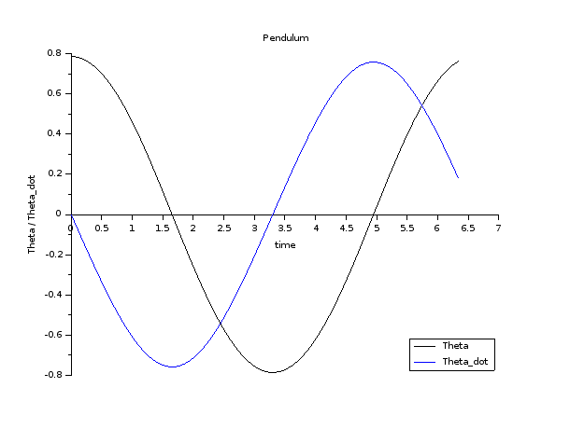OUTPUT: